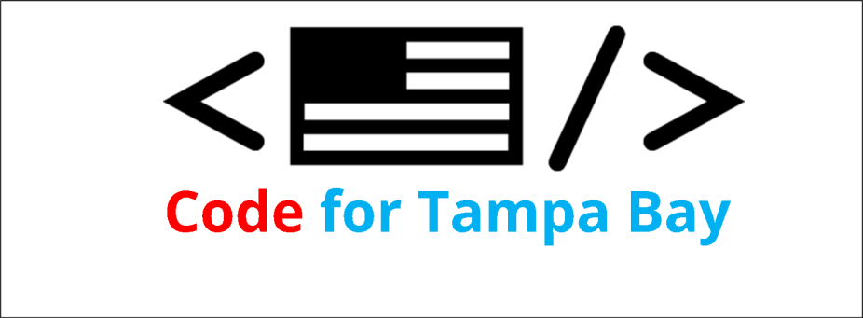

**Willingham Associates, LLC**

**The Eureka! Factory**

**5910 Hammock Woods Drive**

**Odessa, FL 33556**

**813-792-7411**

**EurekaFactory.NET**

**Hillsborough County**

**Economic Development Innovation Initiative Application**

**Events and Industry Promotion Initiatives**

**12. BRIEFLY DESCRIBE THE EVENT OR INDUSTRY PROMOTION (PLEASE LIMIT RESPONSE TO TWO PARAGRAPHS).**

**Hack for Tampa Bay 2015**, will be a local working celebration of the **National Day of Civic Hacking**, sponsored by **Code for Tampa Bay Brigade**. Code for Tampa Bay (CfTB) is a local chapter of Code for America, one of only two in the state of Florida. As a Code for American Brigade, CfTB is an organizing force for local civic engagement, part of a national network of civic-minded volunteers who contribute their skills toward using the web as a platform for local government and community service.

Hack for Tampa Bay will unite technologists, entrepreneurs, developers and other citizens in using open data to improve our communities and the governments that serve them.

**PART B – REVIEW CRITERIA**

**DESCRIBE HOW THE EVENT/PROMOTION MEETS AND/OR EXCEEDS EACH OF THE APPLICABLE REVIEW CRITERIA AS THEY APPLY. EACH REVIEW CRITERIA MUST BE ADDRESSED BELOW.**

**1. DESCRIPTION: HOW THE EVENT/INDUSTRY PROMOTION DRIVES THE GROWTH OF TECHNOLOGY AND INNOVATION START-UPS AND SMALL BUSINESSES IN HILLSBOROUGH COUNTY.**

Hack for Tampa Bay 2015 will drive the growth of technology and innovation by bringing together local business and technology professionals interested in civic engagement, providing a positive environment for networking and collaboration that can help strengthen Tampa Bay’s technology community, bringing technologists and the business community together for the common good of Tampa Bay.

**2. LEVERAGING: DESCRIBE HOW THE PROJECT (i) LEVERAGES PRIVATE SECTOR DOLLARS IN TERMS OF FINANCING, EXPERTISE AND NETWORKING; and (ii) DEMONSTRATES A COLLABORATIVE AND SYNERGISTIC APPROACH**

Hack for Tampa Bay leverages the private sector and Tampa’s technical and creative resources by showcasing the best that Tampa has to offer, in the service of a better Tampa community. By the very nature of the national event– National Day of Civic Hacking – our local event is necessarily a collaborative endeavor, bringing together area professionals and Hillsborough government to work together on solutions for improving services and resources for residents through shared skills.

**3. PERFORMANCE EVALUATION/METRICS. PROVIDE APPROPRIATE CRITERIA AND MILESTONES FOR DETERMINING/MEASURING THE SUCCESS OF THE EVENT/PROMOTION. DEFINE RELEVANT OUTCOME INDICATORS AND TARGETS DURING AND AFTER THE EVENT/PROMOTION (SUCH NUMBER OF EVENT ATTENDEES, ATTENDEE PROFILES, MEDIA COVERAGE, GROWTH IN PARTICIPATION OVER PREVIOUS YEARS, HOTEL NIGHTS, NEW START-UPS FORMED)**

There have been two previous “Hack for Tampa” events in Hillsborough. Code for Tampa Bay was part of the 2014 event, hosted at ITT. While the events were fun and engaging, and resulted in some serious conversation and some interesting solutions to civic challenges, there appears to be no cohesive, long term or ongoing efforts as a result of previous events. With the advent of Code for Tampa Bay, only the second Code for America Brigade in Florida (the other is in Miami), we now have an opportunity to create some measurable change.

As a recognized Code for America Brigade, Code for Tampa Bay is well positioned to provide long term metrics of efforts initiated at Hack for Tampa Bay 2015 and to keep track of efforts that may spin off from Hack Day projects. Additionally, Eureka Factory, which is leading event planning for Hack Tampa Bay 2015, has organized well-respected events like ROBOTICON Tampa Bay and Gulf Coast MakerCon, has a reliable track record for recording event statistics and measuring program growth over a period of years.

**4. ECONOMIC DEVELOPMENT IMPACT: DESCRIBE HOW THE EVENT/INDUSTRY PROMOTION DEMONSTRATES A WELL-THOUGHT OUT IDEA AND MODEL THAT HAS THE POTENTIAL TO BE SUSTAINABLE AND GENERATE ECONOMIC DEVELOPMENT; CREATES PERMANENT LOCAL JOBS AND POTENTIAL FOR SUSTAINED ECONOMIC IMPACT AND GROWTH; GENERATES LOCAL BUSINESS; ADDS VALUE TO THE LOCAL ECONOMY.**

Hackathons follow established protocols, and have proven themselves popular and sustainable, as well as a source of new community-minded app and software development. With the added value of being produced by an approved Code for America Brigade unit, Hack Tampa Bay has a greater potential to provide participants with spin off opportunities on developed apps and business solutions, and certainly brings added value to the local economy by helping improve government resources and civic solutions.

**5. QUALITY OF TEAM: DESCRIBE THE QUALIFICATIONS, TRACK RECORD, AND ABILITY OF THE APPLICANT AND PROFESSIONALS COMPOSING THE EVENT/PROMOTION TEAM TO SUCCESSFULLY EXECUTE THE EVENT/PROMOTION.**

The Hack Tampa Bay team includes professionals from a variety of technology and innovation sectors of Tampa Bay, with a proven track record of event and program production. Planning team members include:

* Terri Willingham, of Willingham Associates, LLC , developers of the John F. Germany makerspace, the Hive, and organizers of ROBOTICON Tampa Bay for the last two years, and Gulf Coast MakerCon,
* John Punzak, Sr. National Sales Director, State & Local Government / Education with Red Hat, an open source software development for enterprise IT, with a broad portfolio of products and services for commercial markets.
* Chris Willingham, Jr. Software Developer, SourceToad, a Tampa web development firm

# Hack Tampa Bay 2015 Budget

|  |  |
| --- | --- |
| Items | Expense |
| Event shirts | $800 |
| Promotional materials (flyers,banners, signage) | $200 |
| Event supplies (badges,notebooks,awards, etc) | $200 |
| Administrative | $800 |
| Total | $2000 |

*As per EDI2 guidelines, food costs, volunteer lodging and in-kind services are not included in this estimate.*

# Letter of Support

## About Code for Tampa Bay

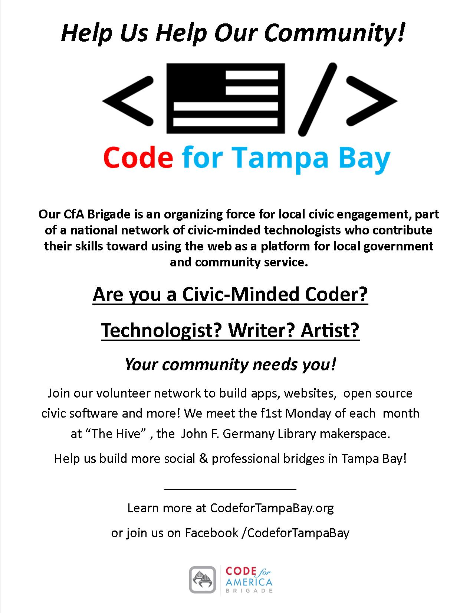

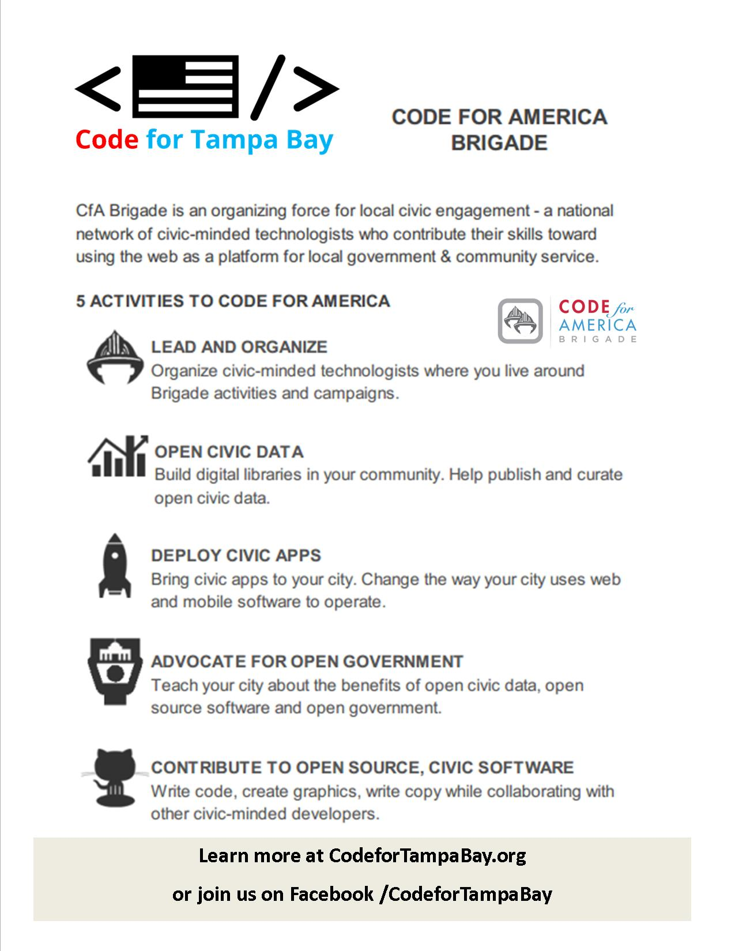

# About National Day of Civic Hacking

For the 2nd event, more than 11,000 citizens representing government, businesses, nonprofits, technologists, and entrepreneurs participated in more than 95 simultaneous civic hacking events in 83 cities across the US – including Tampa - as part of the first ever National Day of Civic Hacking. The 2015 event promises to be even bigger and we look forward to helping grow the event in Tampa.

